|  |  |  |
| --- | --- | --- |
| Year 10 Science  **Task 2: DNA Research**  Science Inquiry; Human Endeavour 10% | Name: |  |
| Due: |  |

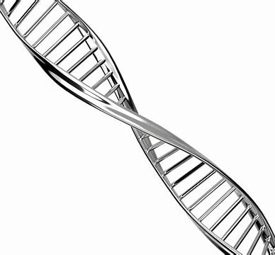

**Part 1: In class**

As a class, brainstorm the kind of questions that people might have about DNA.

**Part 2: Individually**

Identify your target audience.

Select 5 questions to research.

_________________________________________________________________________________________________________________________________________________________________________________________________________________________________________________________________________________________________________________________________________________________________________________________________________________________________________________________________________________________________________________________________________________________________________________________________________________________________________________________________________________

1. Make a dot point summary to answer the questions, collect diagrams and keep a list of references.
2. While you are researching, write down 5 unfamiliar words, then find their meaning (keep references) and write a definition in your own words.
3. Use the information you have collected to make **one** of the following

* a webpage of FAQs (offline)
* an information brochure for high school students
* a children’s story or book
* a letter to householders requesting donations to the “gene bank” foundation
* an advertisement for DNA testing

**You will need to hand in**

* **your *hand written* notes as dot points**
* **your bibliography**
* **your glossary of definitions**
* **webpage/brochure/story/letter/advertisement**

|  |  |  |  |  |  |
| --- | --- | --- | --- | --- | --- |
| **Marking guide /25** | | | | | |
|  | **1** | **2** | **3** | **4** | **5** |
| **Research and notes** | 1 question  answered | 2 questions  answered | 3 questions  answered | 4 questions  answered | 5 questions answered |
| Cut and paste, whole sections or irrelevant information | Cut and paste, whole sentences copied | Dot point but not hand written | Dot points hand written but whole sentences or poorly organised | Hand written, dot points used correctly and organised |
| **Bibliography** | 2 or less references; incorrect format | 3 or more references; correct format |  |  |  |
| **Glossary** | Less than 3 words; definitions are cut and paste | 4 words; defined out of context or not suitable wording for target audience | 5 words, defined in context and in suitable wording for target audience |  |  |
| **Web FAQ/**  **Brochure/Book/Letter or Advertisment** | Uses suitable text and layout convention; | Suitable for target audience |  |  |  |
| One or two diagrams only | 3 or more diagrams |  |  |  |
| Cluttered, unclear or hard to read; incomplete | Visually appealing but lacking in content or clarity; too much or too little text or graphics | Visually appealing, good use of text and graphics | Visually appealing, good use of graphics, text, captions and font/colour |  |
| Only a few spelling or grammar mistakes | No spelling or grammar mistakes |  |  |  |